Curriculum Vitae STEFAN LJILJAK

PERSONAL INFORMATION

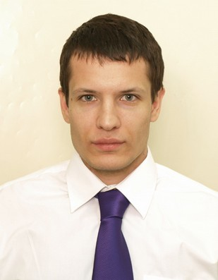

Stefan Ljiljak

 498, Bulevar Kralja Aleksandra, Belgrade, 11000, Serbia  +381606668440

* [stefanljiljak@gmail.com](mailto:stefanljiljak@gmail.com)
* <https://www.linkedin.com/in/stefan-ljiljak-481597194/>

Date of birth 01/05/1988 Nationality Serbian

Profession: front-end web developer ;

graduated jurist with finished judiciary exam.

WORK EXPERIENCE

SEP 30th 2018. - Contract logistics agent

MAY 1st 2019. Kuehne Nagel Belgium

sector: Inbound / Outbound

Contract logistics support in organizing inbound and outbound transport from biggest warehouse of our customer towards Antwerpen port

JUN 15th 2017. - Agent for seafreight logistics

SEP 30th 2018 Kuehne Nagel d.o.o. Beograd, Srbija sector: Seafreight

providing and informing a client about his seafreigth shipment status

01 AUG 2014. -

07 FEB 2016

Ground Service Agent

AirSerbia, Belgrade, Serbia sector Lost and Found Service

01 SEP 2013. –

01 AUG 2014

Legal trainee

Law Office Trifunovic & Cvetkovic, Belgrade, Serbia Bachelor of Laws, LLB, Lawyer

sector Transport Law, Company Law, Tax Law



EDUCATION AND

TRAINING

2019 -

2017 -

HTML, CSS (Bootstrap), JavaScript @

<https://itbootcamp.rs/> - course

<https://www.w3schools.com/> - online

<https://stackskills.com/> - online

Judiciary exam (Ministry of justice of Republic of Serbia)

British council English language course B2 level

2014 -

School for Ground Service Operating Agent

Air Serbia

Aviation Regulations, Dangerous goods transport, Personal grooming, Occupational safety,

software – SABRE, GAETAN, AMADEUS

2009 – 2013

Lawyer, Jurist, LLB

Law College, Belgrade, Serbia

* principal subjects: Insurance Law, Transport Law

College

PERSONAL SKILLS

Mother tongue(s) Serbian

|  |  |  |  |  |  |
| --- | --- | --- | --- | --- | --- |
| Other language(s) | UNDERSTANDING | | SPEAKING | | WRITING |
|  | Listening | Reading | Spoken interaction | Spoken production |  |
| English | excellent | excellent | excellent | excellent | very good |
|  |  |  |  |  |  |
| Russian | good | good | good | good | good |
|  |  |  |  |  |  |

Communication skills Excellent communication skills gained through my experience as Lost and Found Agent

Computer skills MS Office Word, Excel, Power Point, Access, Outlook, Internet

Other skills Excellent in swimming and scuba diving, playing for underwater hockey national team of Serbia, spearfishing

Driving licence ▪ B

ADDITIONAL INFORMATION

Seminars ▪ Public relations:

* + Narration and communication.
  + English language, B2 level (British council diploma)

In free time my hobbies are reading and watching movies preferably science fiction.